CHOIR MANAGEMENT SYSTEM

PROJECT TECHNICAL REPORT

UNIVERSITY OF RWANDA
COLLEGE OF SCIENCE AND TECHNOLOGY
SCHOOL OF ICT
COMPUTER ENGINEERING
CHAPTER 1: INTRODUCTION

1.1 Historical Background
Choirs are important groups in churches, schools, and communities. They organize singers, songs, rehearsals, performances, and other activities. Many choir groups still depend on manual methods to manage information, which can create challenges in communication and organization.
The Choir Management System is a frontend web application prototype designed to demonstrate how digital technologies can improve choir management.

1.2 Problem Statement
Manual management of choir applications, members, attendance, songs, rehearsals, events, and meetings can make information difficult to organize and access.

1.3 Objectives of the Project
General Objective:
To design and develop a Choir Management System using HTML, CSS, and JavaScript.
Specific Objectives:
- Create a public choir information website.
- Provide an application interface for new members.
- Design an administrator management interface.
- Design a member access interface.
- Implement JavaScript interactions.

1.4 Expected Outcomes
The project provides a frontend prototype containing visitor, administrator, and member interfaces with interactive features.

1.5 Project Rationale
The system demonstrates how web technologies can support better organization, communication, and learning within choir communities.

CHAPTER 2: SYSTEM ANALYSIS AND DESIGN

2.1 System Analysis
The system has three main categories of users:
Visitor:
- Views choir information.
- Selects choir information.
- Applies to join a choir.
Administrator:
- Reviews applications.
- Manages members.
- Records attendance.
- Manages songs.
- Manages rehearsals, events, and meetings.
Member:
- Accesses songs.
- Views rehearsals and events.
- Manages profile information.

2.2 System Design
The system design describes the relationship between authentication, administrator functions, and member functions.

Figure 2.1: Functional System Design Diagram
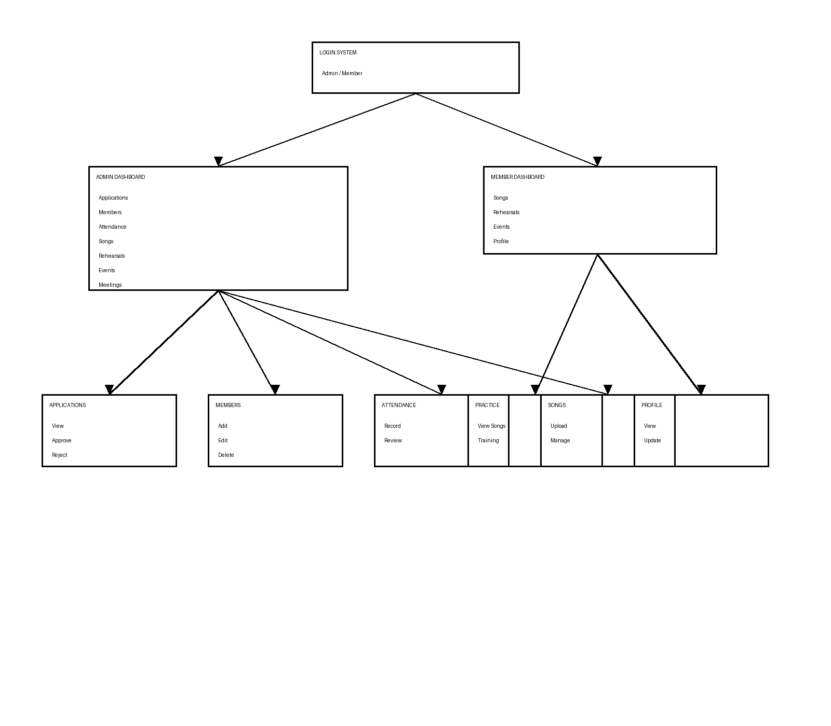
The diagram shows the main modules of the Choir Management System. The administrator dashboard provides management functions while the member dashboard provides access to choir resources.

2.3 Future System Design Improvements
- Online member practice through the system.
- AI tools for improving singing skills.
- Voice analysis and personalized feedback.
- Direct choir song uploads and online practice materials.
- Backend and database integration.
- Secure authentication and cloud storage.

CHAPTER 3: IMPLEMENTATION

3.1 Technologies Used
HTML:
Used to create the structure of the web pages.
CSS:
Used for styling, layouts, navigation, forms, and visual design.
JavaScript:
Used for form validation and frontend interactions.

CHAPTER 4: CONCLUSION AND RECOMMENDATIONS

4.1 Conclusion
The Choir Management System achieved its objective of creating a frontend prototype that demonstrates how choir activities can be organized digitally using web technologies.

4.2 Recommendations
Future versions should include:
- Backend development.
- Database integration.
- Real user accounts.
- AI-powered singing improvement tools.
- Online choir learning and song sharing.

APPENDIX
GitHub Repository: https://github.com/Joyeuxe-25/choir
Deployment Link: https://joyeuxe-25.github.io/choir/
Emails and Password:
Admin:
Email: admin@test.com
Password: Admin123
Member:
Email: member@test.com
Password: Member123

